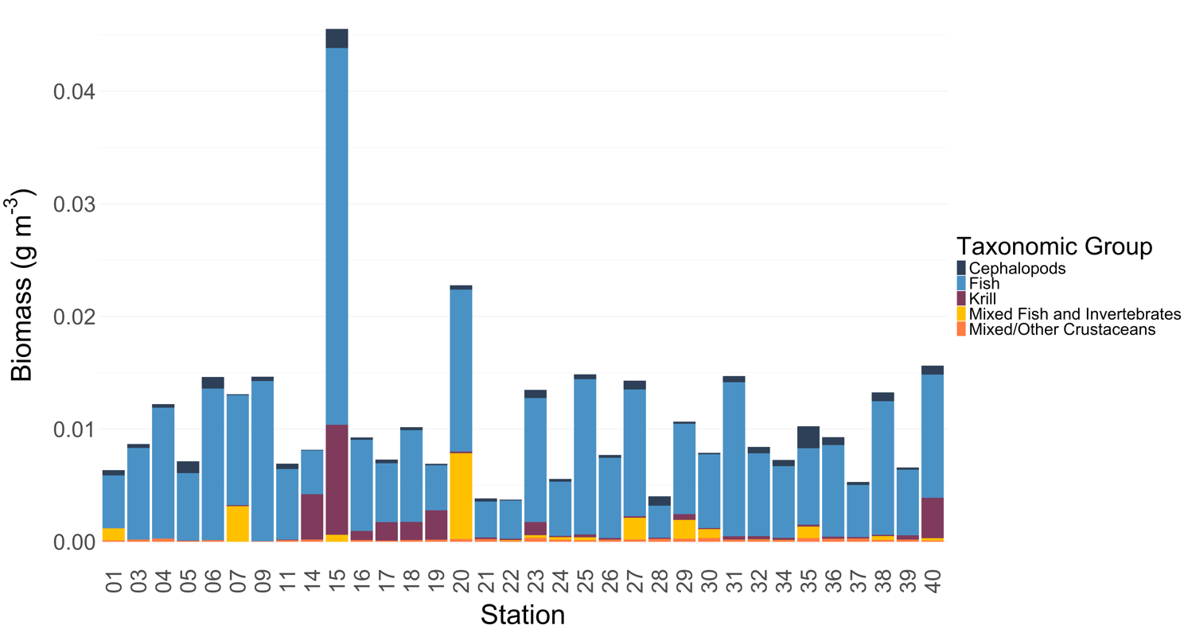



Taxonomic Group

Cephalopods

Fish

Krill

Mixed fish/invertebrates

Mixed/crustaceans

